Velociraptor Lab Solution
Step 1:
Go to the Hunt Artifact tab
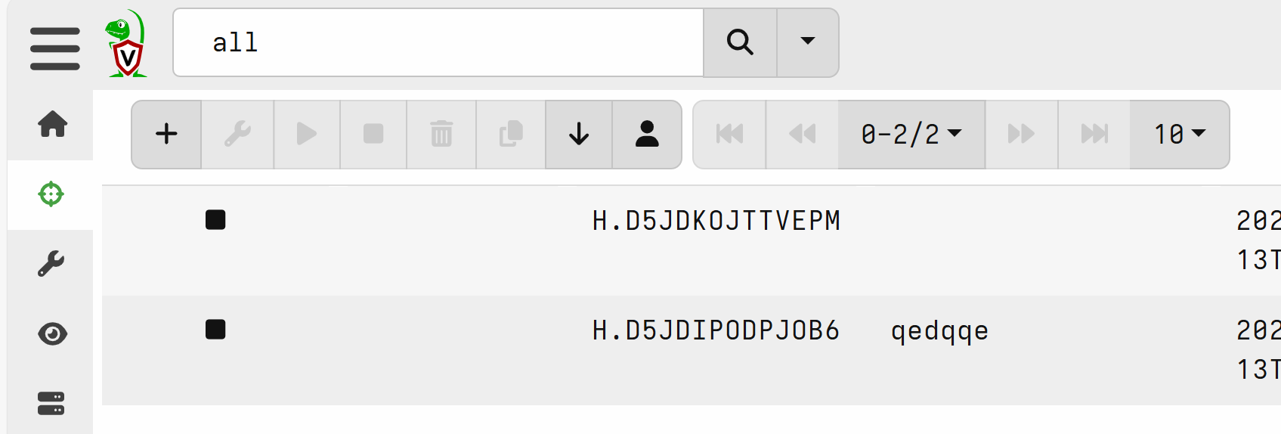

Step 2:
Select new Hunt
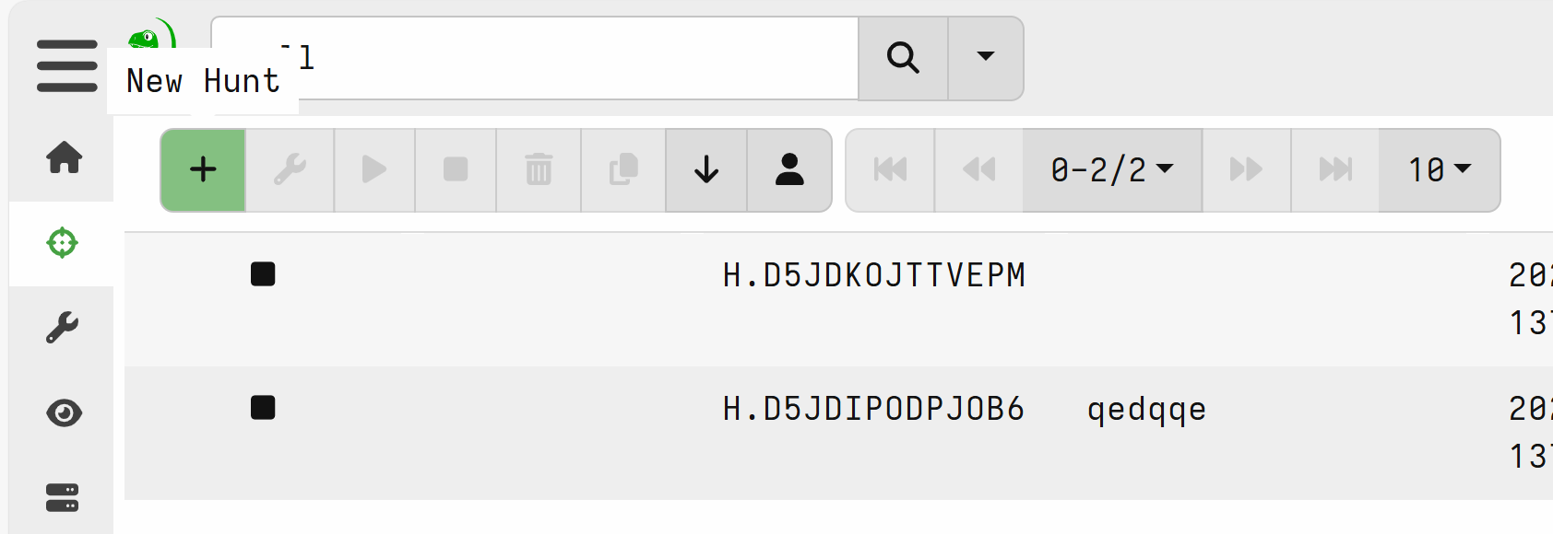

Step 3:
Start you Hunt by naming it ensure you have good naming convention so others using velociraptor know who is using it.
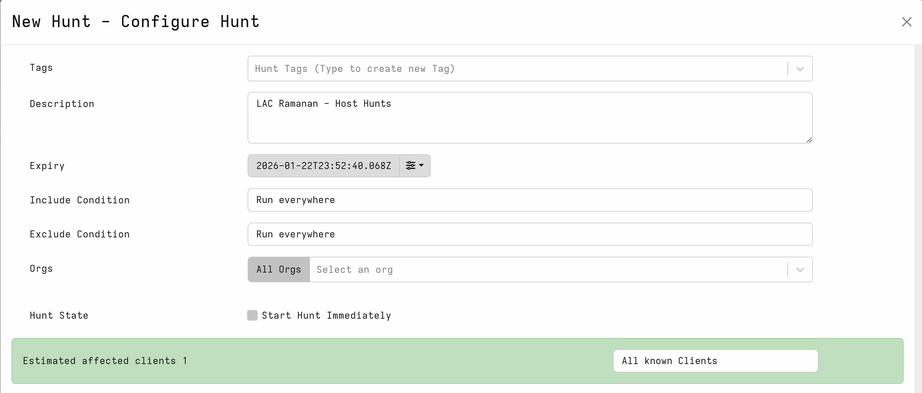

Step 4:
Select your Hunt Artifacts
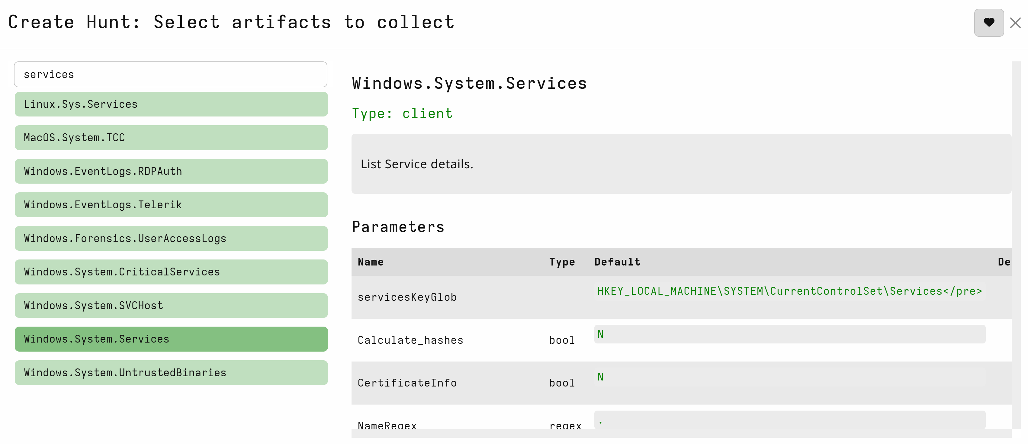

Step 5:
Next part is to configure your parameters
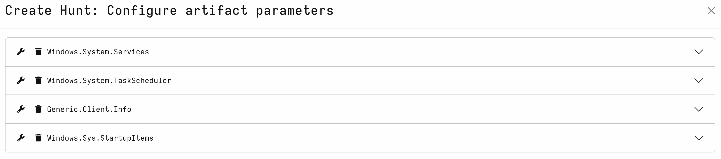
Step 6:
Able to configure your hunt and give it certain strings or parameters too look for
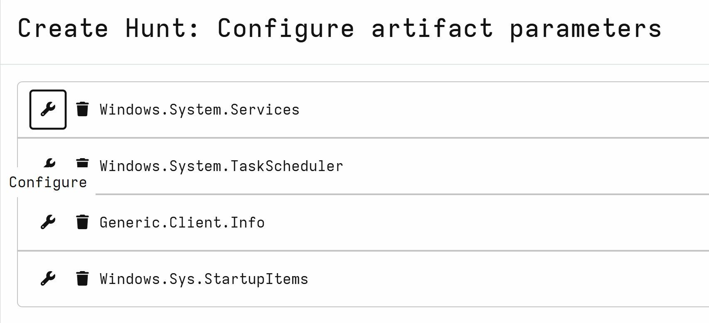

Step 7:
Change the CPU usage of the hunt to ensure you don’t overload the remote machine.
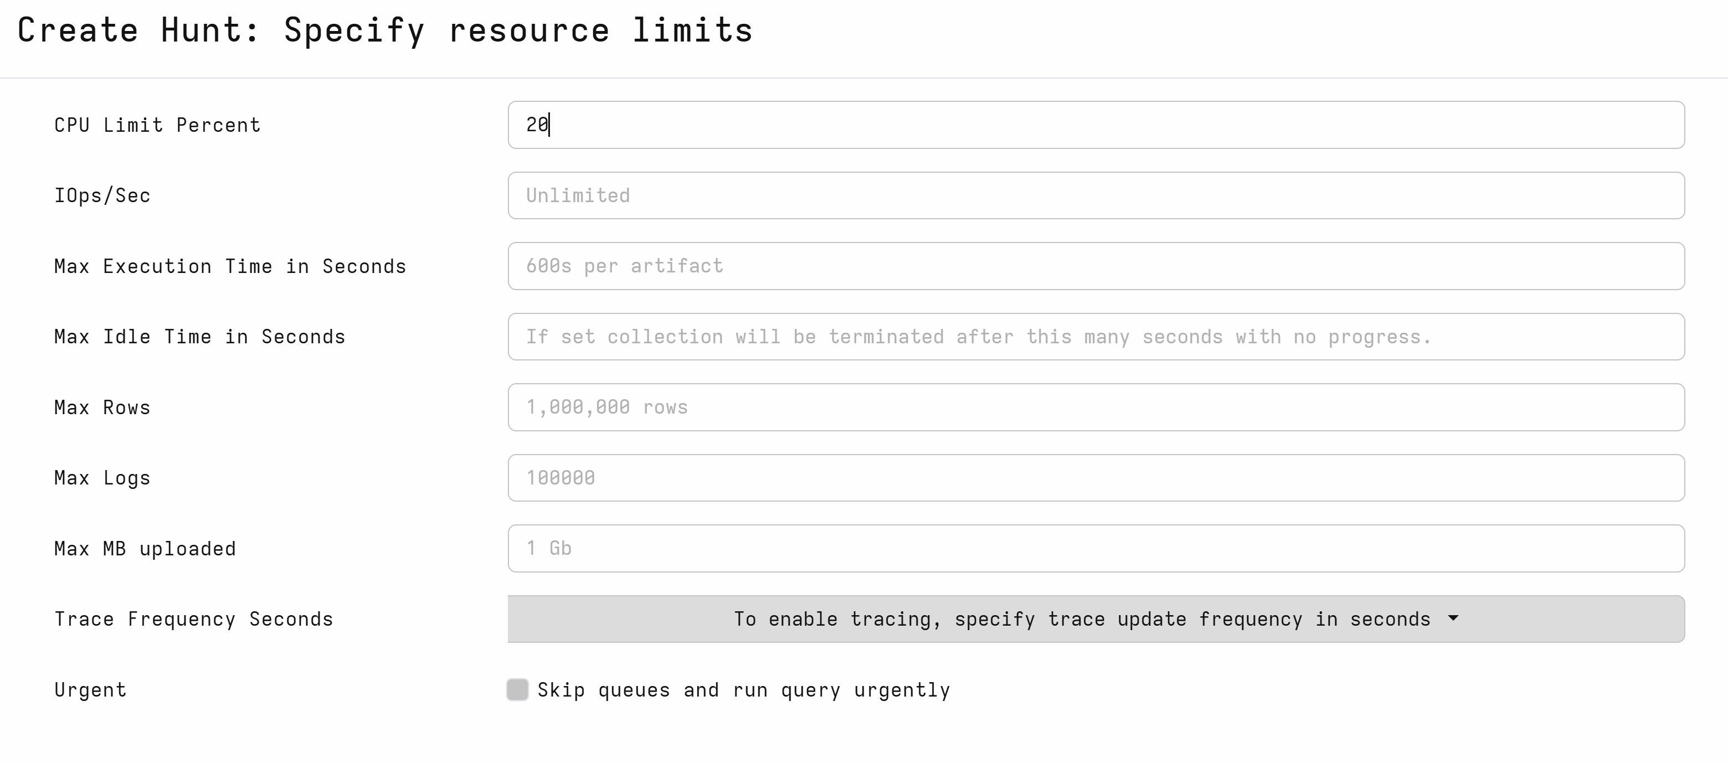

Step 8:
Run the hunt after completion
